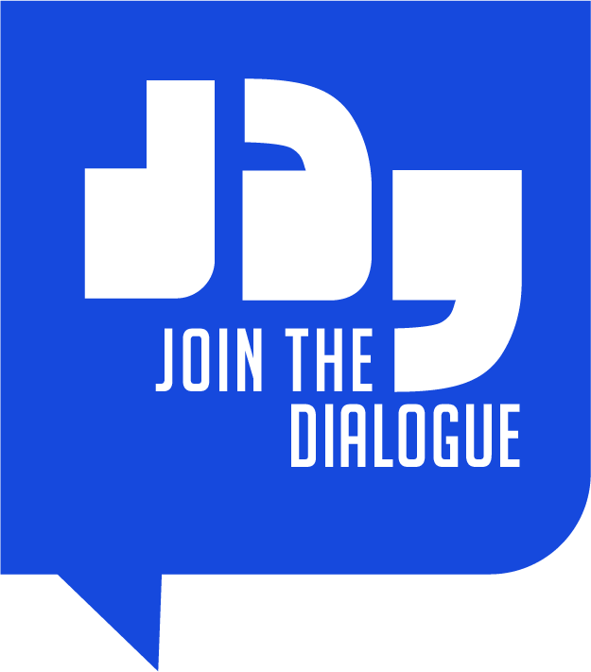
Support to civil society participation in the implementation of EU trade agreements
EU-Central America Association Agreement
Workshop Terms of Reference
Thursday 12th November 2020

Activity: Workshop for DAG members on the Impact of the Covid-19 Pandemic on Trade and Sustainable development
Expert(s): 1 Moderator and 1 Key Expert

Date of Assignment: Thursday 12th November 2020

Place of Assignment: Home-Based (Virtual – via Webex)

- Introduction to the Project
The Overall Objective of this project is to support the implementation of TSD chapters of EU Trade Agreements through consistent, visible and increased participation of the civil society.
For each trade agreement two DAGs are established, one representing EU civil society and one representing the civil society of the trade partner. They meet separately several times a year in each of these their domestic configurations and jointly once a year, alternatively in Brussels and in the partner country or countries as a Joint Civil Society Forum or as a Joint Consultative Committee. With an overall goal of supporting existing DAGs or establishing new ones and maintaining dynamic, motivated and self-sustaining DAGs across EU trade agreements, the contractor, in agreement with the Contracting Authority and in cooperation with the REX secretariat, will ensure the logistical and secretarial aspects of the DAG meetings under each trade agreement. The contractor will also provide capacity building in the form of benchmarking and subsequent implementation of best practices and desk studies. Finally, the contractor will provide support in the field of communication.
DMI and its Consortium partners’ contribution to this will take form in the achievement of four specific Purposes, as defined in the Project Terms of Reference:
- P1: Organising the meetings of DAGs;
- P2: Providing, in agreement with the DAG members and alongside the EESC (specifically the REX secretariat) secretarial support for the meetings of civil society organised in relation to EU trade agreements;
- P3: Capacity building and implementing international best practice to maintain and increase the meaningful participation of both EU and partner countries’ civil society in Trade Agreements;
- P4: Provide support to the communication of the EU DAGs’ work to the public via existing dedicated web pages and by social media so as to reach a wide audience.

The Results to be achieved by the Project and the contractor are as follows:
- R1: All meetings are organised in a timely and efficient manner with travel arrangements, information distributed, and expenses processed within agreed deadlines;
- R2: All meeting documents including agendas, minutes and reports as requested and approved by the DAG drafted to a sufficient level of quality and approved within agreed deadlines;
- R3: Ensuring civil society groups are aware of, and act accordingly to, their roles and responsibilities provided by the Trade Agreements;
- R4: News of meetings, public meeting documents and project progress are regularly communicated to a growing audience.

The Project is thus structured around five Tasks:
- Task 1: Logistical management of the meetings;
- Task 2: Secretarial support;
- Task 3: Organisation of workshops during joint meetings;
- Task 4: Strengthening the EU DAGs; and
- Task 5: Communication.

- Specific Activity background and outline
The activity is part of the Task 3 of the ToR and contributes to Result 3.
The Project received a request to explore the possibility to develop, organize and implement a workshop for both the EU DAG and the Central American DAG, to enhance their role under the TSD provisions within the EU-Central America Association Agreement.
The workshop is expected to be held on 12th November, 2020 from 16:00-19:00. Specifically, in the context of the Covid-19 sanitary situation, the meeting will be held virtually, via Webex. It will take place in the context of the TSD sub-committee meeting, EU-Central America DAG-to-DAG meeting, and Civil Society Forum. These events will also take place in a virtual format, via Webex, in November.
According to the agreed timeframe of the Activity, the half-day workshop on “Impact of the Covid-19 Pandemic on Trade and Sustainable development”, will be delivered by 1 expert, to a group of DAG members both from the EU and from the Central American regional DAGs. The 2nd expert will be a Moderator of the event.
The details of the Activity, including the Experts’ profiles, expected deliverables and work-plan are mentioned below.

- Description of the Activity: Objectives and results to be achieved
Technical assistance is requested from 2 senior experts to conduct and moderate a workshop. The workshop aims to facilitate the DAG members’ understanding and discussions over possible implications of the Covid-19 crisis on Trade and Sustainable Development, as well as its effects on implementing the EU-Central America Association Agreement.
The objectives of the workshop are:
- Help individual DAG members to develop a wider understanding of the implications of the pandemic on Trade and Sustainable Development, in each of their countries and in general globally;
- Facilitate discussions between DAG members on the challenges presented by the current situation.
- Encourage greater Civil Society participation within the framework of the Association Agreement and communicate on best practices as to how to achieve this.

- Description of Experts’ Time Plan

PHASING OF TASKS | Man-days per expert | Timing
Phase I: Preparation and Needs Assessment work  (desk work – home-based):  Assessing the current situation, elaboration of tailor-made workshop (including material e.g. presentation, potential case studies etc.).  Phase II: Delivering the workshop  (in the field)  Delivery of the half-day workshop.  Drafting of the outcome document.  Phase III: Reporting  (home-based)  Reporting on the workshop (short summary, presentation of the material used, and lessons learned) and submitting an outcome document | 1 day  0,5 day  0,5 day | Before 12th November 2020 – final material should be shared maximum 2 working days ahead of the workshop  12th November 2020 – Half day during the workshop.  Within 10 working days following the workshop
- Description of Experts’ Profiles
Expert 1 – Workshop Moderator
General Qualifications | - Fluent Spanish speaker (the workshop is to be carried out in Spanish, with English translation);  - Ability to work and draft in English;  - Outstanding intercultural communication skills.
Specific Experience | - Proven hands-on experience in facilitating workshops, including in team coaching, animating and moderating debates and discussions, finding common ground among different agendas and objectives in a results-oriented way;  - Ability to moderate discussions and animate debates;  - Knowledge of the functioning of the EU institutions;  - Knowledge of the political situation in Central America, and previous experience in the region, would be an asset.
Expert’s  Inputs | 0,5 Man Days

Expert 2 – The Impact of the Covid-19 Pandemic on Trade and Sustainable Development
General Qualifications | - Fluent Spanish speaker (the workshop is to be carried out in Spanish, with English Translation);  - Ability to work and draft in English;  - Outstanding intercultural communication skills.
Specific Experience | - Proven experience dealing with Trade and Sustainable Development and the effects of Covid-19 on these elements, in an academic context;  - Knowledge of the TSD chapter in the context of the EU-Central America Association Agreement and the role of civil society participation in AA and FTA implementation;  - Ability to present, guide debates and moderate discussions;  - Knowledge of the functioning of the EU institutions and of the inter-regional DAG country relations;  - Knowledge of the political situation in Central America, and previous experience in the region, would be an asset.
Expert’s  Inputs | 2 man-days

- Period of Assignment and Location

The Workshop will be carried out remotely, via Webex (which will be launched from the EESC Headquarters in Bruessels).
It will be held on Thursday 12th November 2020, from 16:00-19:00.

- Workshop Agenda

A detailed agenda will be elaborated in close collaboration with the selected Experts and the beneficiaries and will be annexed to these ToR.

